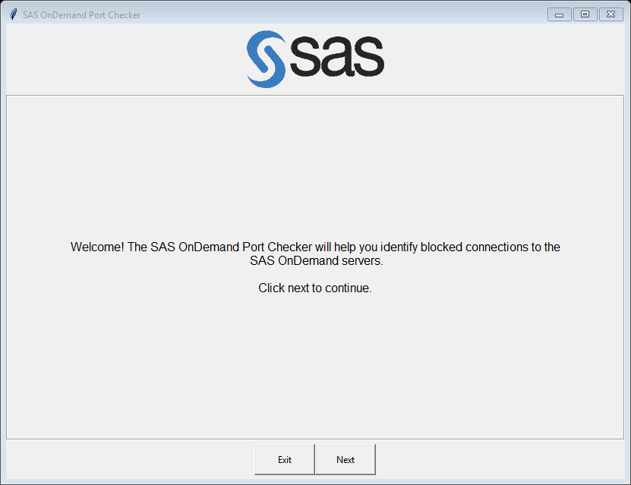

Goes to next step of program (next page)

Exits the program

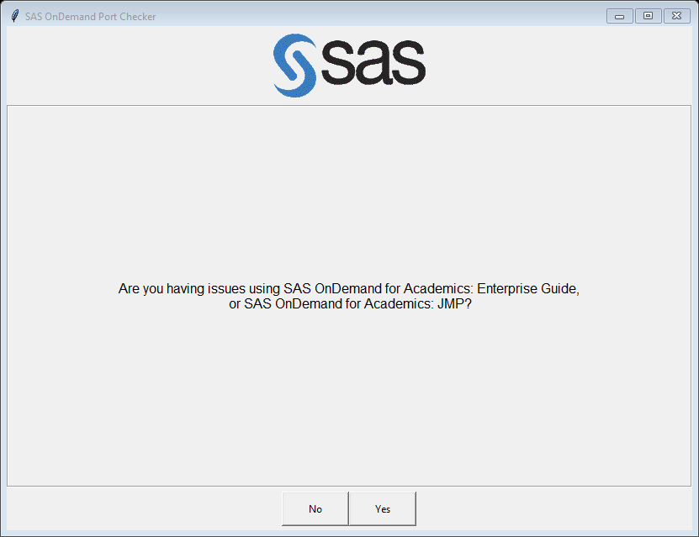

Includes

Includes the Global and Tier 3 Hostnames, along with the **Tier 2 Hostnames:**

US: odaomr-usw2.oda.sas.com

US: odaws01-usw2.oda.sas.com

US: odaws02-usw2.oda.sas.com

US: odaws03-usw2.oda.sas.com

US: odaws04-usw2.oda.sas.com

EU: odaomr-euw1.oda.sas.com

EU: odaws01-euw1.oda.sas.com

EU: odaws02-euw1.oda.sas.com

AP: odaomr-apse1.oda.sas.com

AP: odaws01-apse1.oda.sas.com

AP: odaws02-apse1.oda.sas.com

Includes only Global and Tier 3 Hostnames

**Global Hostnames**:

GLOBAL: welcome.oda.sas.com

GLOBAL: status.oda.sas.com

**Tier 3 Hostnames**:

US: odamid-usw2.oda.sas.com

EU: odamid-euw1.oda.sas.com

AP: odamid-apse1.oda.sas.com

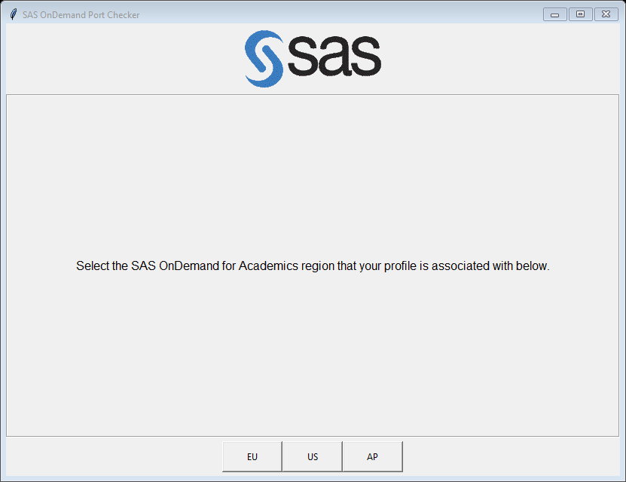

Uses AP Hostnames when checking for blocked ports.

* If user clicked **YES** on previous page, see page 8.
* If user clicks **NO** on previous page, see page 9.

Uses EU Hostnames when checking for blocked ports.

* If user clicked **YES** on previous page, see page 4.
* If user clicks **NO** on previous page, see page 5.

Uses US Hostnames when checking for blocked ports.

* If user clicked **YES** on previous page, see page 6.
* If user clicks **NO** on previous page, see page 7.

User Chose: YES, EU­­

(return to page 3)

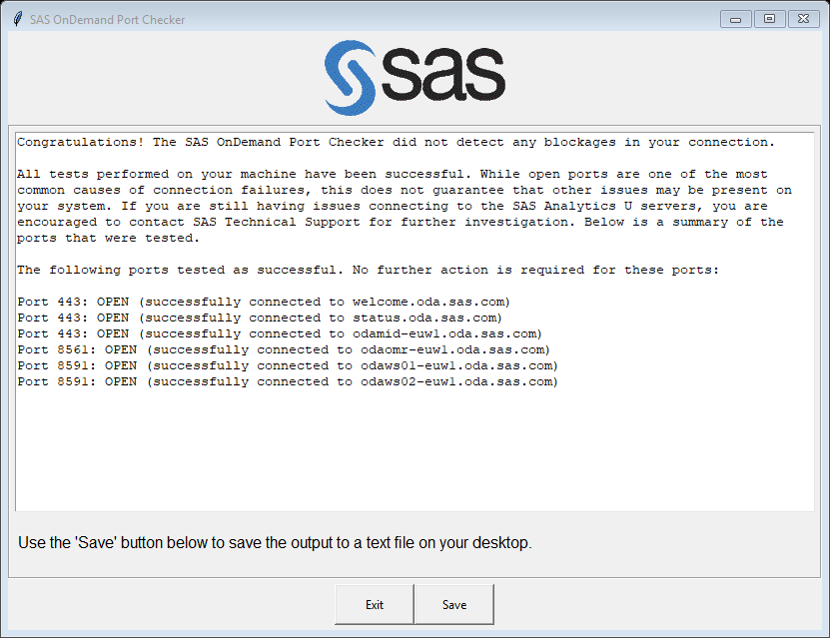

Saves the output text in the textbox above to the user’s Desktop as a text file. The user can send this to Technical Support for further troubleshooting if necessary.

Exits the program

User Chose: NO, EU

(return to page 3)

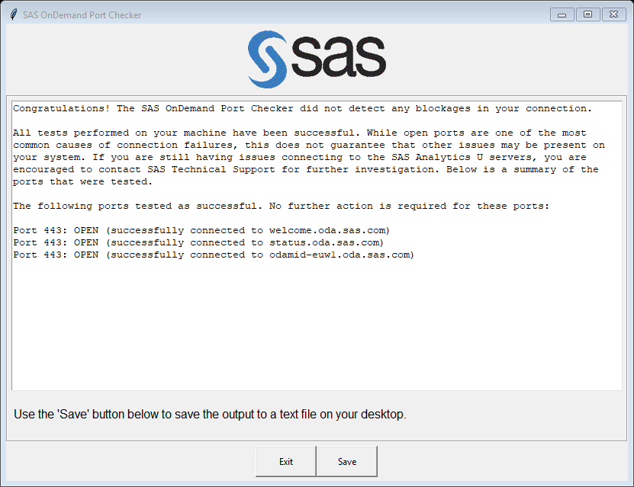

Saves the output text in the textbox above to the user’s Desktop as a text file. The user can send this to Technical Support for further troubleshooting if necessary.

Exits the program

User Chose: YES, US

(return to page 3)

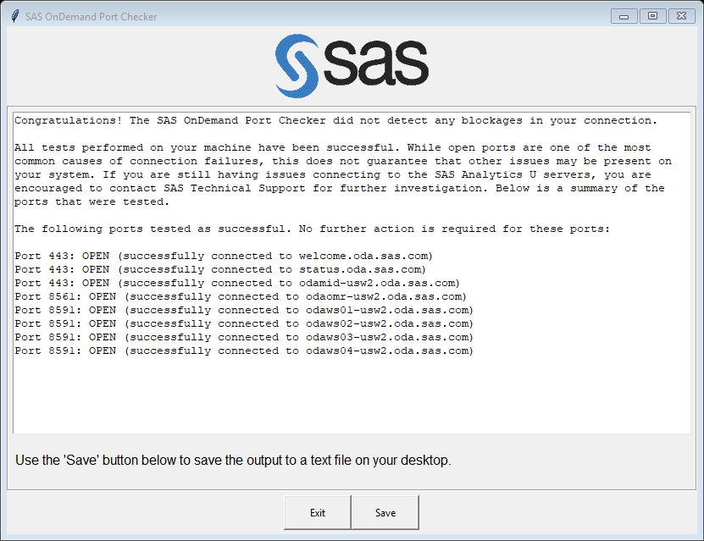

Saves the output text in the textbox above to the user’s Desktop as a text file. The user can send this to Technical Support for further troubleshooting if necessary.

Exits the program

User Chose: NO, US

(return to page 3)

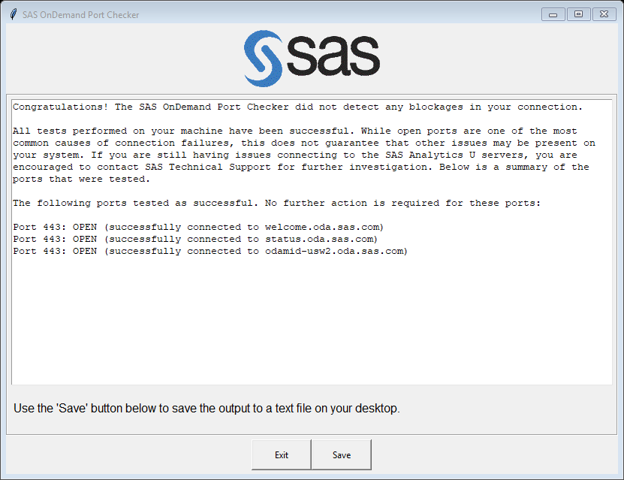

Saves the output text in the textbox above to the user’s Desktop as a text file. The user can send this to Technical Support for further troubleshooting if necessary.

Exits the program

User Chose: YES, AP

(return to page 3)

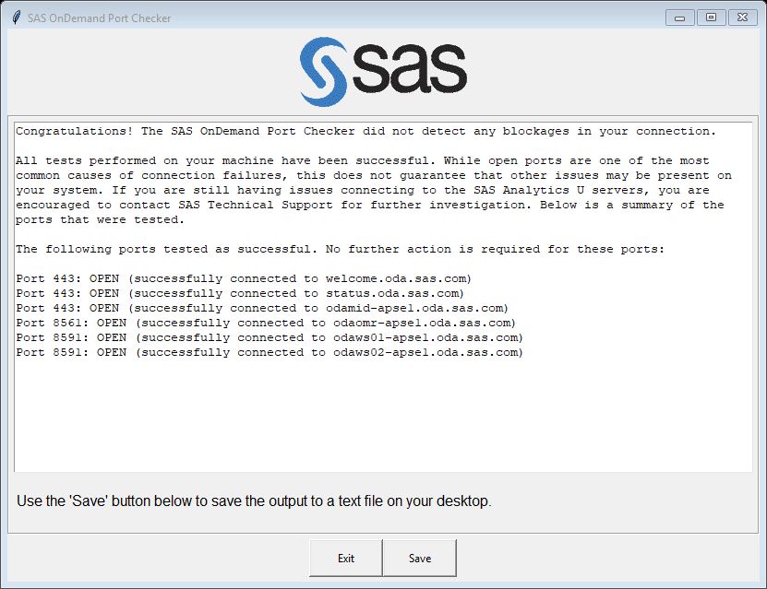

Saves the output text in the textbox above to the user’s Desktop as a text file. The user can send this to Technical Support for further troubleshooting if necessary.

Exits the program

User Chose: NO, AP

(return to page 3)

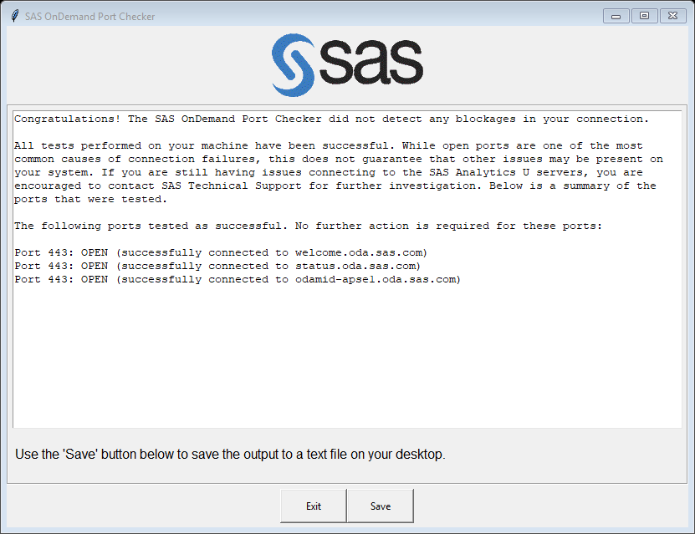

Saves the output text in the textbox above to the user’s Desktop as a text file. The user can send this to Technical Support for further troubleshooting if necessary.

Exits the program